Agenda:

1. Planning Phase: JIRA
2. Source Code Management: GIT
3. Code Review And Quaity Check : SonarQube(With help of PMD , Check style, FindBugs etc...)
4. Build Management : Maven
5. UNIT Testing : JUNIT
6. Packaging : JAR, WAR (In maven also we can packge )
7. Artifact Repository System Mgmt : Nexus
8. Deploy to QA Boxes: Chef, Puppet, Ansible | Docker
9. Testing : Selinium
10. Code Coverage : JACOCO
11. Release :
Addd: Load runner integrate in testing phase with the help of maven
====================JIRA==========================================
JIRA default port number is :8080
==============================================
Note : In JIRA workflow is : TODO, In Progress, Done
Steps to do in a issue resolving:
--> Anyone who want to create a ticket (Like Issue, Task, etc..) they will create it and someone like dispatcher or TL or on our own we need to assign it on our name: Change the state from TODO to In Progress
--->
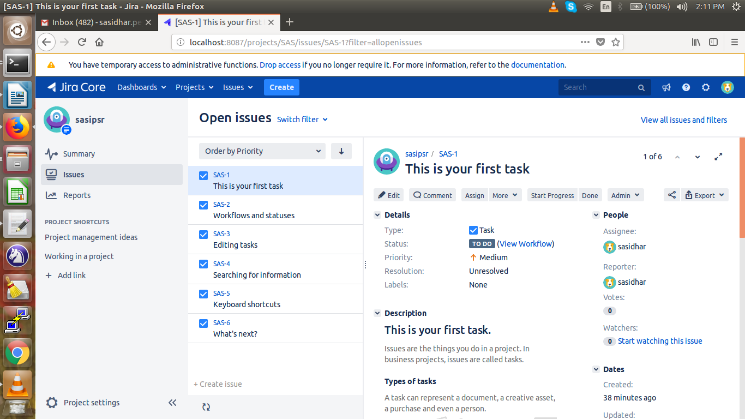

Here: 1.Dash Board--->a.View System Dash Board, b.managa Dash Board.
a. System Dash board Contains Introduction, Assgined to me , Company Jira

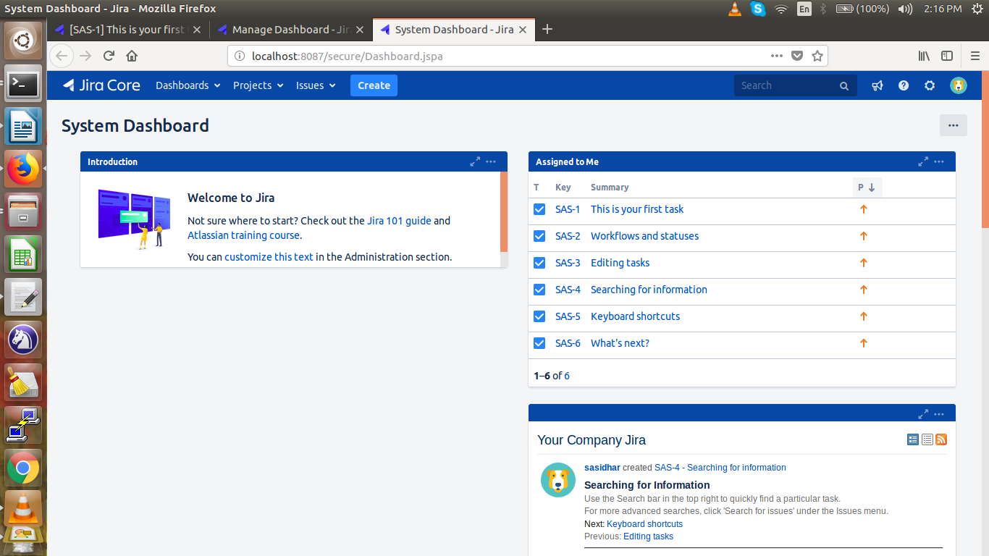

b). In manage dash board we can create our own dash board.
2. Projects:
In projects a). Current Project, b).View All Projects, c). Import External Project, d).Create Project
3. Issues:
a). Search For issue
b). Recent Issues,
c). Import Issues from CSV,
d). My open issues*
e). Reported by me.
4. Create:
create issue:
Project Name:
Issue Type: For regular issues: Task
Summary: Short infomation about issue
Reporter: Creater
Attachment:
Due Date:
Description:
Assignee: To whom we are assigning
Priority:
Lables:
Create:
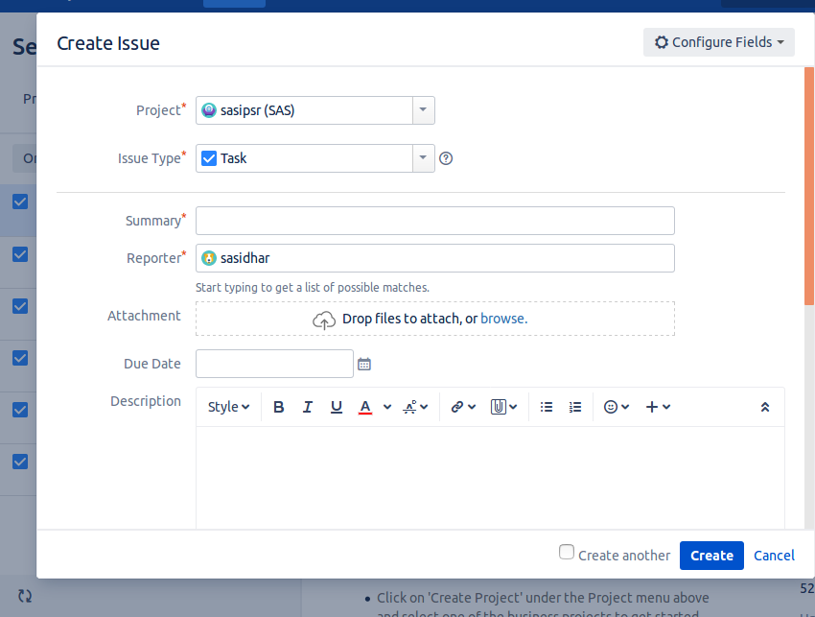

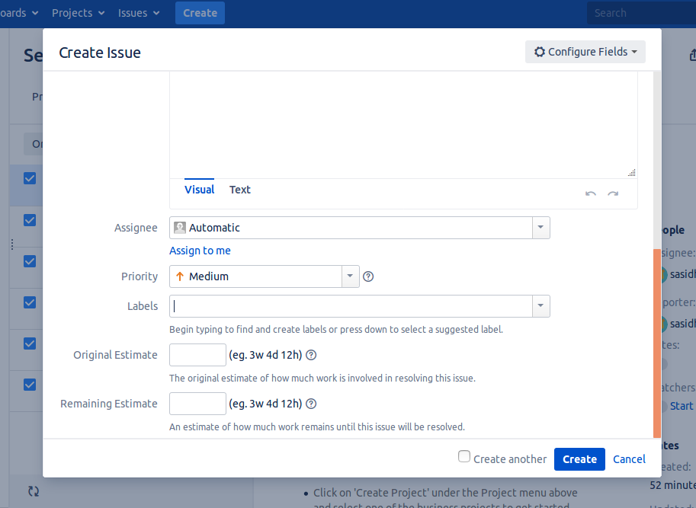

=====================================================================
In one issue following things are there:
1. Edit: we can edit the issue details ( create the issue fileds)
2. Commnts: we can add our comment ans also we can see existing comments
3.Assign: We can assign to our name aslo assign to others
4. More:In mote section we have lot of options:
Main is watchers: If our manager or TL want to watch our issue status we can add their ID here.
Log work means Time Spent, Date Started, Work Description etc...:
We can Attach Files:
Create Subtask:
Convert to sub task:
Move: We can move current issue to new project or new issue type
Link: Link this issue to another issue.
Clone”
Lables:
Delete:
5.Start Progress*: From Todo to In Progress
6. Done: After completion of issue
7.Admin:

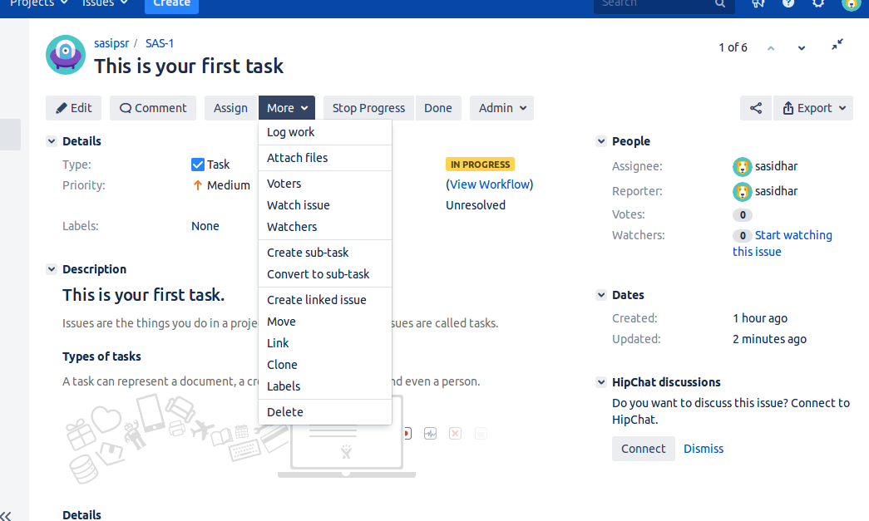

===========================================================
Integrating GIT with JIRA:
By using “git integraton for JIRA “ addon (like plugin) We can do this

How to add addons(Plugins) In Jira:
Go to Top right settigns --> Addons --> 1. marketPlace, 2*. Find New addons, 3.*manage addons
--> click on Find new addons and serach and new addon --> To activate addon --> after installing the addon click on manage addon and select the addon and click on configure
Ex: Install and configure “git configure for JIRa”
--> Find new addons--. Search: git for jira --> install --> manage addons ---> select git for jira ---> configure ---> Need to add configuration details( Connect to Git repository: username and password of git private repo )
======================================================
====================SONARQUBE==============================
-->Sonarqube has the rules coming from PMD , Checkstyple, Find bugs based on these it will review the code.
---> SONARQUBE default port number is : 9000
---> For code review we required 3 elements:
1. SonarQube Server : Install the Sonar server
2.Source Code: Which source code need to be check
3. Sonar Scanner:
Steps to do manual this process:
a. Download Source code and sonarScanner into one folder.
b. We need to change the sonarserver URL in sonarscanner-->conf-->sonarscannerproperties--> Edit the file and change default URL.(EX: bydefault it’s localhost:9000 and if server URL is 192.168.1.2 then we need to change it to 192.168.1.2:9000 )
c. Run the sonarscanner under bin where our source code exist.
Ex: If our source code exist in the path of : /home/sasidhar/sonar/source and our sonarscanner exist in the path of /home/sasidhar/sonae/sonarscanner/bin/sonar-scanner.bat and run this
/home/sasidhar/sonarscanner/bin/sonar-scanner..bat
(Note: This command execute in source code folder , In this folder we should have src along with sonar property file contains the infoemation about which language , path to the source code, ...etc)

Sonarscaneer acts as a broker in between the source code and sonar server talk to ech other
Sonar scanner will read the property file in the source code folder ans based upon this file sonarscanner hit the sonatserver and get the “quality Profiles”

server
Data base
rules
Source code
scanner
1
2
3
4
(Property File)
5
6
7
8

2. scanner Hit the source conde, 3. gather the property file Informatiom And 4. Hit the server,5. Pull the quality profiles based on the property fil information And applied to source code.6. Pull the final report ,7. Export Report to databse, 8. Displays the sonarqube dashboard from DB.

====================BUILD MANAGEMENT(MAVEN)==============
> mvn compile
> mvn test
> mvn package
> mvn deploy

==================UNIT TESTING: ===============================

================PACKAGING: JAR, WAR=========================

=================Artifact Repo:NEXUS===========================

Manually Upload Our artifact (WAR, JAR) to Nexus repository through Maven:

> In Order to that we have to do two modifications:
1 pom.xml file
2.setting.xml

Create Repositoy in Nexus Dash Board:
Usually we use two types of repository:
1. Release Repository,
Click on ADD --> Hosted repository --> Type Repository ID & Repository Name& Repository Policy: Release --> Save
2. Snapshot repository.
>Click on ADD --> Hosted repository --> Type Repository ID & Repository Name& Repository Policy: Snapshot --> Save

1. Pom.Xml modification: Tell to maven where our repository located(URL)

Under Distibution management we have to add repository Id , name and URL

<distributionManagement>
<repository>
<id>deployment</id>
<name>Internal ReleaseS1</name>
<url>http://13.232.83.212:8081/nexus/content//repositories/mph</url>
</repository>

<snapshotRepository>
<id>deployment</id>
<name>Internal Release</name>
<url>http://13.232.83.212:8081/nexus/content/repository/mphsnapshot/</url>
</snapshotRepository>
</distributionManagement>

2. Modify the maven setting.xml
cd $MAVEN_HOME/conf/setting.xml
vim setting.xml
<servers>
<id>deployment</id>
<username>nexu_repositry_username</username>
<password>nexus_repository_password</password>

(NOTE: id(ex:deployment should be same in all 3 places(1. In pom.xml repository, 2. In Pom.xml snapshot repository, 3. In settinh.xml . In above example we mentioed “deployment” is our id name in all 3 places )

---> Manually upload to Nexsu repository:
$ mvn deply( Run this command where we have the src and pom.xml placed)
If build success means artifacts uploaded to nexus repo successfully.
We can checck in nexu repo and click on link -->com --> we can check here

===================JENKINS====================================
1. SonarQube Integration:

--> we have to add “sonar” or “sonar scanner” plugin a)--> Go to manage Jenkins --> Manage Plugins --> Available --> search for sonar --> Install without restart
b). Configure Sonar in Jenkins:
In two Places we have to set the configure settings. (Configure System&Global Tool configuration Settings)
1. Manage Jenkins --> Configure System --> SonarQube Serverss:Name:(Ex:Like sonar), Server URL:SonarQube server URL(Ex:http://127.0.0.1:9000), Server Authentication Token: Go to SonarQube Dash Board --> Administration(TopRight Corner)---> My account --> Security --> Generate New Token:Enter the name --> Generate --> Copy the key --> Paste under Server Authentication Token section --> Save & Apply

2. Manage Jenkins--> Global tool configuration --> Sonar Qube Scanner --> Add SonarQube scanner --> Name:(scanner)--> Install automatically -->Save
Configure SonarQube in a Job: Go to the job --> configure --> Build --> Execute sonarQube scanner --> Save

If it’s configured succesfully sonarqube icon will display on sonarqube dash board

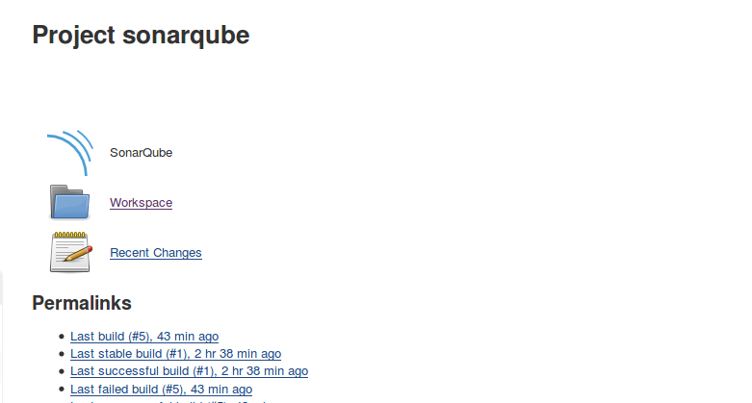

After build success if we click on above icon(sonarqube) it will redirect to the sonarqube dashboard automatically(To our project). Here we can check code smells , Coverage
, Duplications. Issues categorized major, Minor etc..--->

===================Maven Automation=============================
Stages: mvn compile
mvn test
mvn package
mvn deploy
1. cteate a job for maven compile:
click on new item-->Git-->Source code URL--->Build:Execcute top level maven management--> Select maven & Goal : clean
2.cteate a job for maven test:
click on new item-->Git-->Source code URL--->Build:Execcute top level maven management--> Select maven & Goal : test
(If we want to generate Junit test reports in “Post Build action” we have to select-->Publish Junit test result report --> Test report XML: Enter the path to xml file (Ex:/target/reports/*.xml)--> Save
We can check in the Test Result of that build ex: --> Go to Job --> Go to Build --> In the left panel --> Test Result --> we can check pass, fail and etc

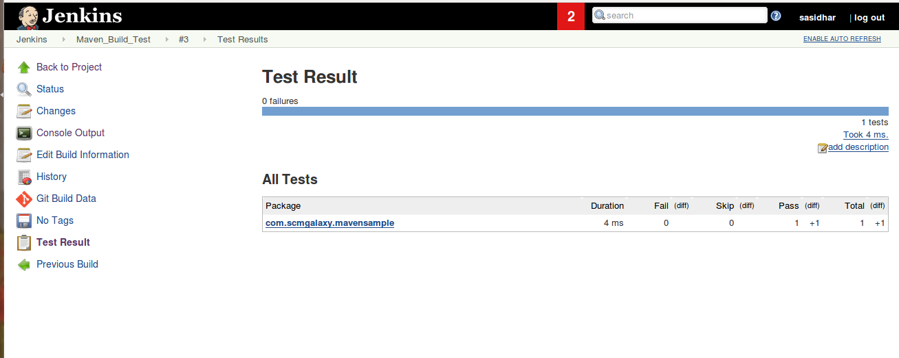

In SonarQube also we can check the Junit Test report:( For this we have to add utility(Like plugin) --> Go to adminstration-->My Account--> System--> Update Center -->Available-->Search for Junit (or) pdf plugin or etc plugins)
--> Go to SonarQube Test report --> Go to Project -->

3.cteate a job for maven package:
click on new item-->Git-->Source code URL--->Build:Execcute top level maven management--> Select maven & Goal : package

4. cteate a job for maven deploy:
click on new item-->Git-->Source code URL--->Build:Execcute top level maven management--> Select maven & Goal : deploy
In this job in order to deploy our package we need to modify pom.xml and maven setting.xml( In pom.xml we have to give the repo Id, Name, URL of nexus repo undeer Distribution Management(Note: Here normol repo and snapshot repo should be there) and in maven setting.xml we need to modify the server details(-->MavenHome-->conf-->setting.xml--> under server detals add id, username & password of nexus repository.)
(Note : Here id in the pom.xml normol repo, Id of snapshot repo and Id in setting.xml should be same)

========================================================
Deployment Life cycle:

SonarQube --> Build --> UT --> Package --> DeploytoNexus repo

we can configure pipeline for all these with the help of build pipeline.

======================================================
Deploy pacage availbbale in the Nexus to N numner of servers(Chef, Ansible etc..)
With the help of containerbased technology like docker

CookBooks copy the content from nexus and put it into the QA servers

To add node list:

knife bootstrap ipaddress –ssh-user USER --sudo --identity-file IDENTITY_FILE --node-name node1

Ex: knife bootstrap 172.31.37.116 –ssh-user ec2-user --sudo --identity-file /home/sasidhar/CICD/chef-repo/node.pem --node-name node1
knife ssh 'name:node1' 'sudo chef-client' --ssh-user ec2-user --identity-file /home/sasidhar/CICD/chef-repo/node.pem

(OR)

knife bootstrap 172.17.0.2 -x sasipsr -P 12345 -N node4 –sudo

(OR)

